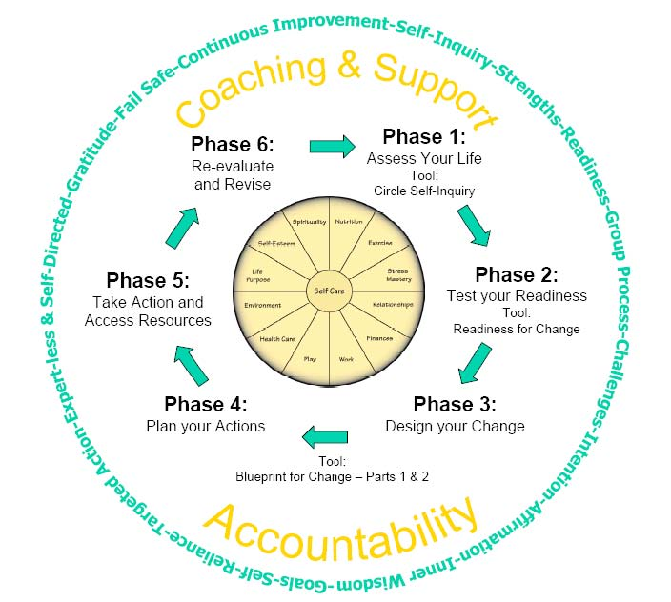
Circle of Life
Living the Life you Love
A group coaching experience:
set your intentions, accomplish your goals, and love your life
Is your life unfolding with a sense of purpose and meaning? Are you truly delighted by your path?
The Circle of Life can make the difference. With the support of a skilled life coach, the power of the group, and clear tools, you can truly make powerful decisions about where your life is headed and how you intend to live it. By focusing on what actually matters to you, you can prioritize meaningful changes and ensure that you’re taking care of yourself along the way. You can have the life you want.
What will happen in the group?
- You’ll complete a Circle of Life Assessment, evaluating 12 aspects of your life
- You’ll conduct your own Readiness for Change Assessment
- You’ll begin a powerful process of: Intention/Challenge/Affirmation/Action/Accountability
- You’ll create a personal step-by-step strategy plan and schedule that really works for you
- You’ll access your own inner wisdom and power
- You’ll invite the wisdom, experiences, ideas & support of the group
- You’ll create on-going support for yourself
- You’ll experience the empowerment that comes from setting powerful intentions & witnessing change.

Who is this group for? Anyone ready to make a commitment to living a more purposeful life; limited to 8 people
When will this group meet? 5 consecutive Saturday mornings (one 3-hour kick-off and four 2-hour sessions) followed by 2 monthly Saturday morning follow-up sessions
What materials will I need? Circle of Life Participant’s Manual – provided at the first meeting
How much will it cost? $500 for the entire series and all materials

Who will be running this group? Melissa Parkerton, MA is a life coach with a great passion for supporting people through growth and transitions. For more information about Melissa or the Circle of Life, please call 310-9131619 or send an email to piyarisoma@hotmail.com.
