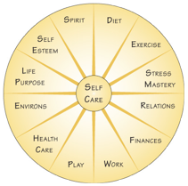
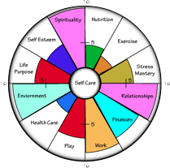
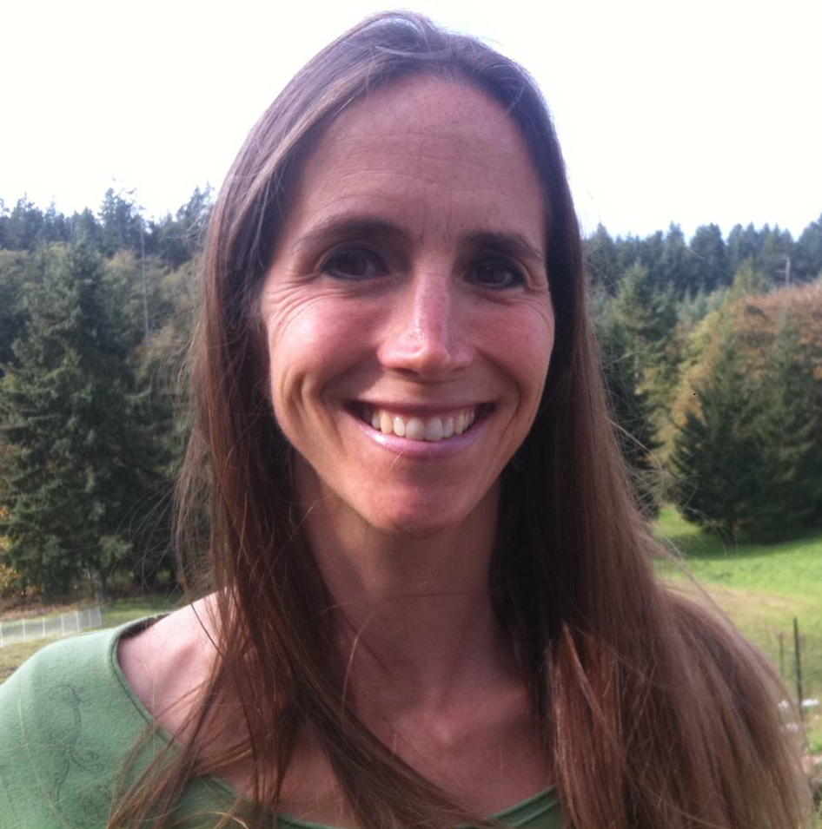
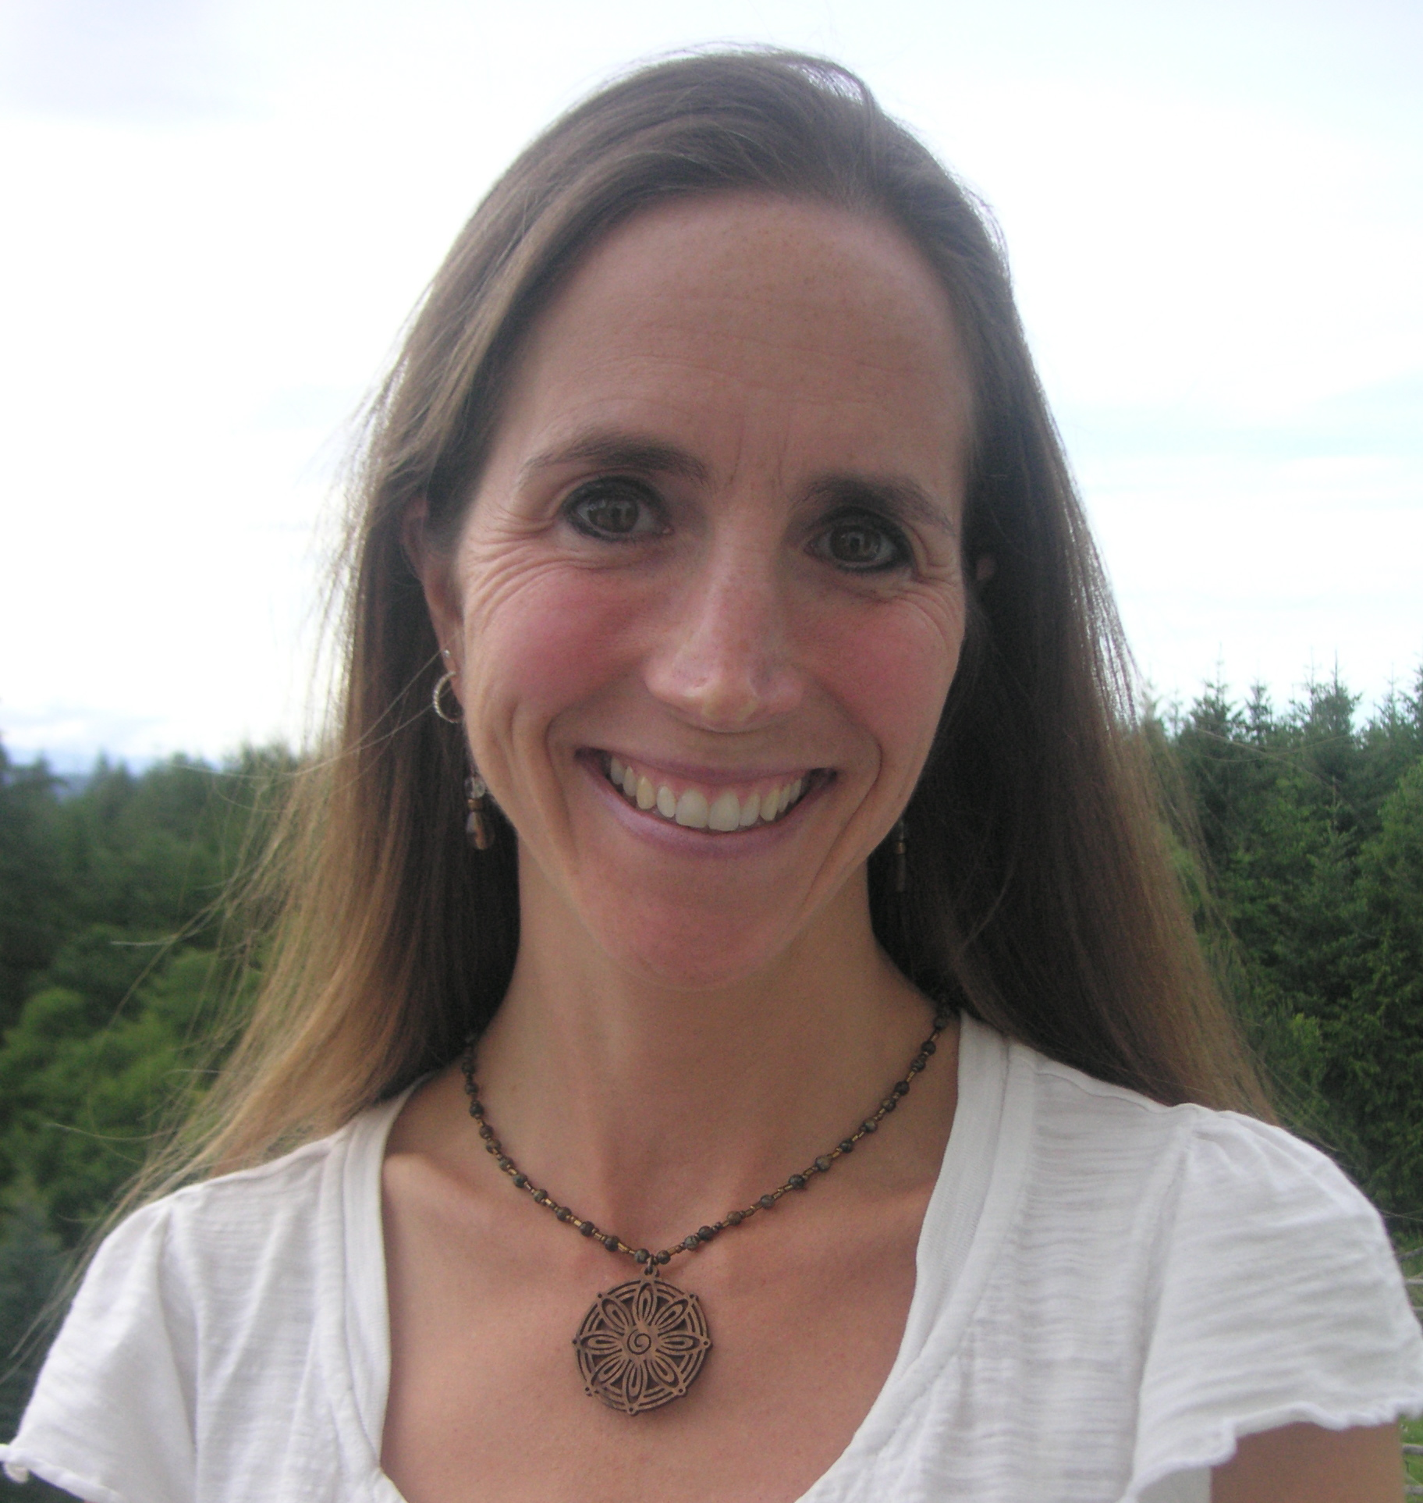
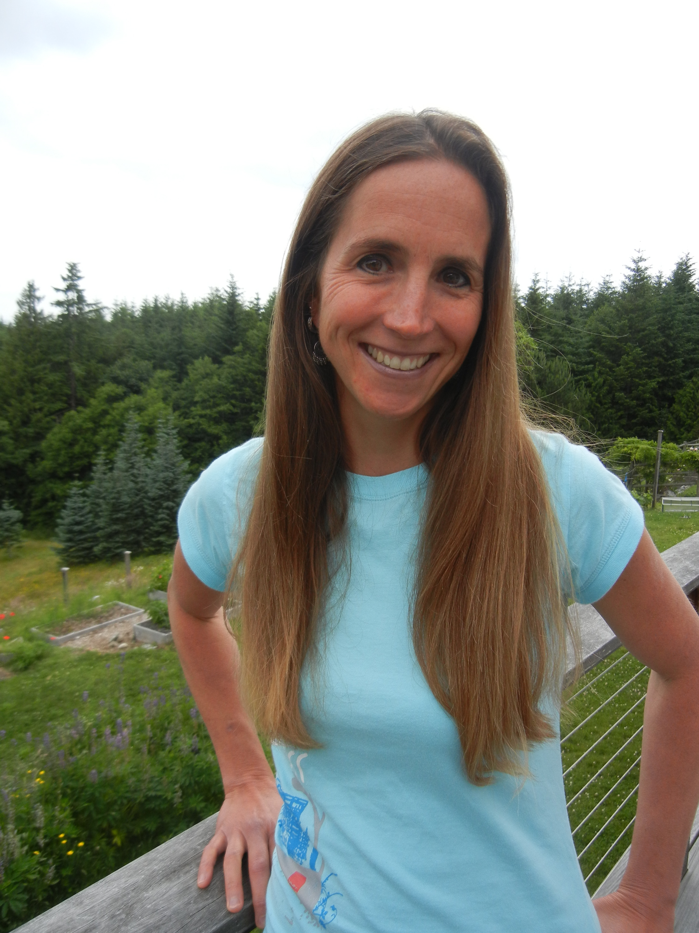

† CIRCLE OF LIFE ¢

If you could change anything in your life, what would it be?

Are you stuck in a rut, not able to move forward?

In addition to being a credentialed and licensed Social Worker, I am a certified Circle of Life™ Health & Wellness Coach, ready to come alongside you as a support and encourager to help guide you as you seek balance and wellness.

Helping you evaluate the full spectrum of your life

In the Circle of Life you will be fully supported in learning how to:
- Balance your life: work, self-care, relationships, play, finances, family.
- Reduce stress and energize yourself with 1-5 minute self-care practices you can easily weave into your daily routine.
- Navigate major life choices in a focused, healthy and supported way.
- Utilize your strengths effectively.
- Make skillful life changes and stop guessing what to do next.

I will walk beside you on this path

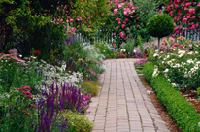

for families, businesses, And Retreats

While individual clients are coached by phone or in person once a week or twice a month as necessary, groups of 6 to 12 people meet for a series of sessions. Each member works on their individual goals while being facilitated in a safe and supportive group learning process, either by phone or in person.

Since 1987, thousands of people from every walk of life have achieved their health and life goals by using the Circle of Life system, creating success and well-being in all areas of life.

Coaching

Health & Wellness

Please contact me today

Is there an area of your life - nutrition, stress mastery, health care, life purpose - that needs immediate attention?

Please let me know how I can assist you to evaluate the full spectrum of your life. Whether it is via phone or email, I look forward to speaking with you soon.

I wish you much nourishment on your path of health and wellness!

Learn more at www.SusanJames.me

for groups and individuals

206.972.3530 Susan@SusanJames.me

Coaching

Health & Wellness

for families and businesses

Susan James, LICSW

Susan James, LICSW
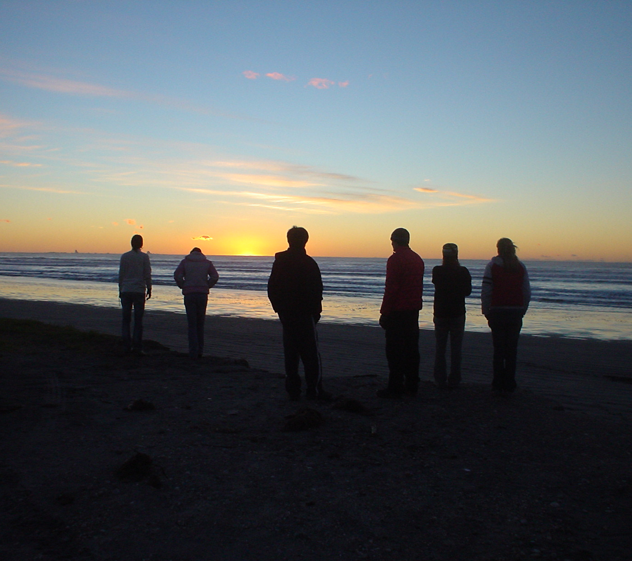
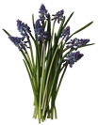
What is Circle of Life Coaching?
Health & Wellness Coaching is a way to maximize personal effectiveness.
The type of coaching I do is referred to as the "Circle of Life" process which means we evaluate the full spectrum of one's life, from nutrition and exercise to life purpose and spirituality.
My role is to foster this process with you and bring forth the "power, strengths, and inner wisdom" of a group or individual clients.

How does it work?
The Circle of Life process is holistic including twelve different life areas.
No matter where you are, or what struggles you face, the Circle of Life coaching process will help you identify your strengths, define your goals, and move forward in life.
Who is coaching for?
People from all walks of life have found the Circle of Life system to be effective and personally rewarding. Corporate executives, nurses, social workers, teachers, students, business teams, senior citizens, ministry professionals, therapists, and parents have all experienced success in their lives and work.

Choose what works for you
This coaching can be tailored to individuals, schools, businesses, organizations, and families.
My groups generally meet over a two to four month period of time, in a variety of formats to meet client needs. The process is designed to teach practical stress mastery skills, as well as tools for achieving lasting change. Participants enjoy the support of their peers and benefit from
shared resources and experiences.
Individual coaching and wellness consulting is also available. A more customized approach is an effective way to encourage change, move through obstacles, and achieve your goals. Coaching sessions can be in person, via email, skype, phone, or a combination of these modes.
I can assist you in a Six-Phase Approach to:
Learn an intention; recognize challenges and strengths
Clarify and set goals along with affirmations
Schedule realistic action steps,
Review and set your own custom process,
Set-up accountability, and
Engage in an effective and supportive personal improvement process that will take you from where you are to where you want to be!

What are others saying?

“To my amazement, I found taking small steps leveraged big life changes! And when I worked on the area of “work” it positively affected 6 other aspects of my life that I also wanted to improve!”

–Steve Klein, Teacher

“At my work wellness group coaching sessions, I made breakthroughs in 3 key areas of my life. I increased my income by 20% even during an economic downturn. I turned two draining work relationships into more energizing ones and I added daily 1 -3 min self-care practices that greatly reduce my stress, keep me healthier and happier.”

– Allison Keller, Financial Advisor

“I came into the Circle group divorced, bankrupt, and with breast cancer. I left empowered. I wrote a book, became a national speaker, and I am cancer free.”

–Bev Kirkhart

“I was depressed and overweight. In my Circle coaching, I assessed what drains me and what gives me energy. By implementing self-care, I have a new job that I love, lost 40 pounds and feel energized!”

–S. Beale, Registered Nurse

Health & Wellness Coaching

You will be fully supported
Nutrition & Diet | Emotions and Self Esteem | Financial Health
Exercise & Fitness | Spirituality | Creativity & Play
Stress Mastery | Relationships & Family | Self-Care
Work & Career | Environment | Life Purpose & Service

